Prototype-Midterm

|  |  |
| --- | --- |
| **Student Name/ID Number:** | Wildan Luqmanul Hakim/STTB |
| **Academic Year:** | 2022 |
| **Unit Assessor:** | Arvinder Kaur |
| **Project Title:** | CPL-Midterm |
| **Issue Date:** | 6 March 2023 |
| **Submission Date:** | 15 March 2023 |
| **Internal Verifier Name:** |  |
| **Date:** | 15 March 2023 |

|  |
| --- |
| **Learner declaration** |
| I certify that the work submitted for this assignment is my own and research sources are fully acknowledged.    Student signature: Date: 15 March 2023 |

1. **A summary of the project's objectives, scope, and requirements, as outlined in the project brief or proposal.**

The objective of this project is to research and analyze the current inventory management system used by Jumpstart and propose a more efficient and effective system. The scope of the project includes the implementation of a new software system, data migration from the old system to the new system, user training and support, and system maintenance and upgrades. The proposed system aims to improve the accuracy and efficiency of the inventory management process, increase the speed of data retrieval, reduce the time spent on manual data entry and management, and improve the overall quality of service provided to customers. The project requires a comprehensive understanding of Jumpstart's current inventory management system, as well as thorough testing and evaluation of the proposed solution to ensure its success.

1. **A brief description of the technologies, programming languages, and frameworks used to develop the website.**

The development environment consisted of VS Code as the code editor, Google Chrome as the browser for testing and debugging, and Postman API for testing the API endpoints. The data for the website is stored in a MongoDB database hosted on the MongoDB Atlas platform.

The programming languages used to create the website include HTML, CSS, JavaScript, and TypeScript. HTML is used to create the structure and content of the web pages, while CSS is used to style and layout the pages and JavaScript is used to add interactivity and dynamic behavior to the website.

The frontend framework used for this website is NextJS, which is a React-based framework that provides server-side rendering, automatic code splitting, and optimized performance. TailwindCSS was used as the CSS framework to provide pre-built styles and utilities that can be easily customized.

For the backend, ExpressJS was used as the Node.js framework to handle the API requests and responses. Mongoose was used as the object data modeling (ODM) library to interact with the MongoDB database and simplify the data access and manipulation.

1. **Design and other design assets that illustrate the website's layout, color scheme, typography, and overall user interface design.  
     
   Home Page  
   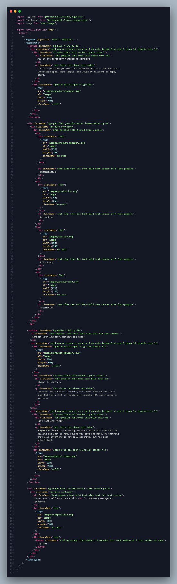**

**Contact Page  
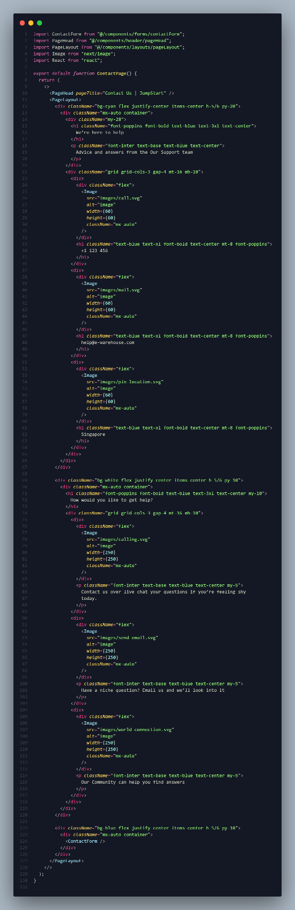**

**About Us Page  
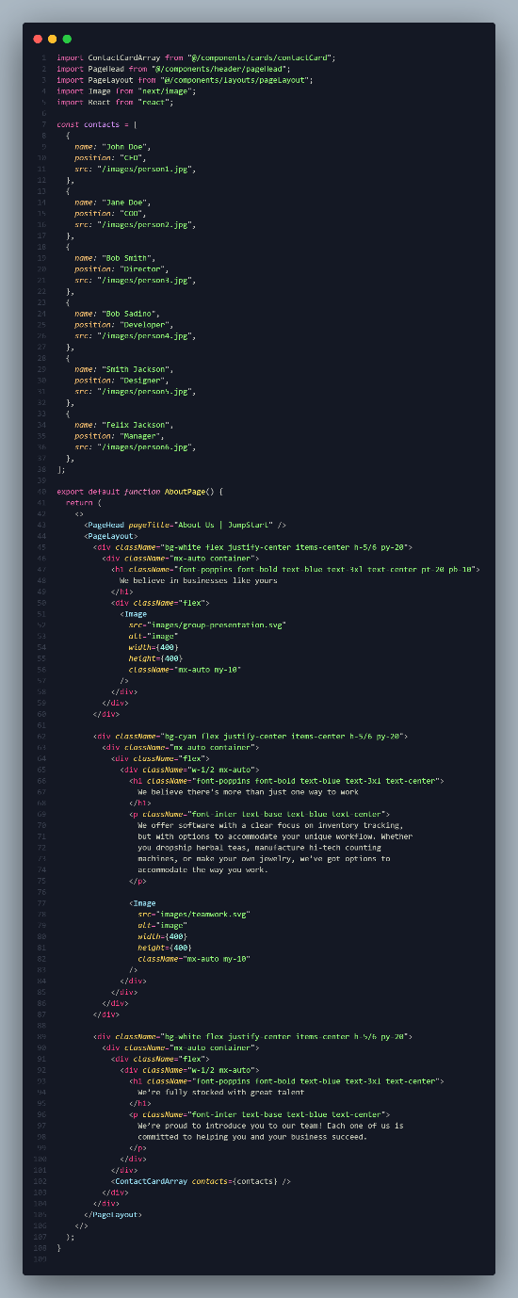**

**Login  
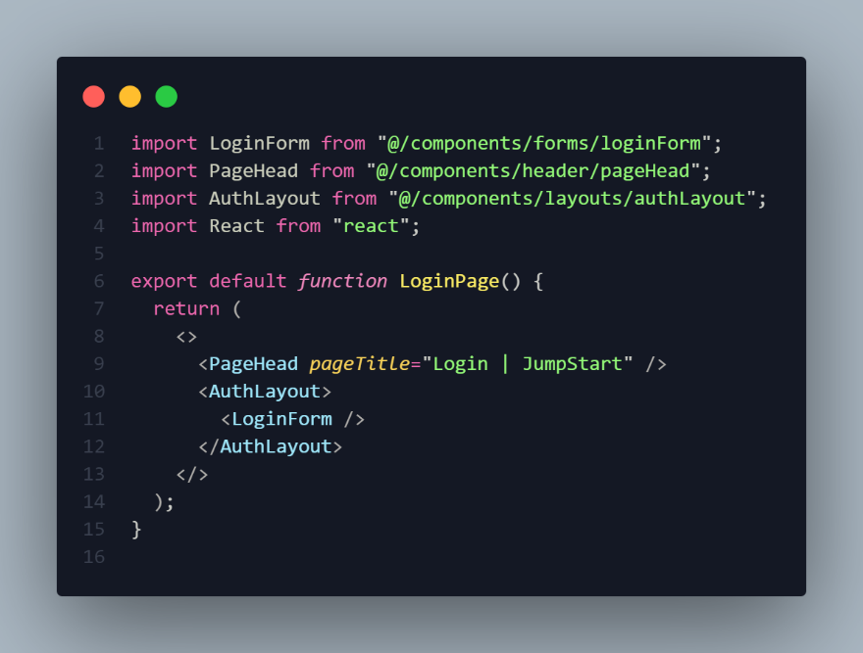**

**Register  
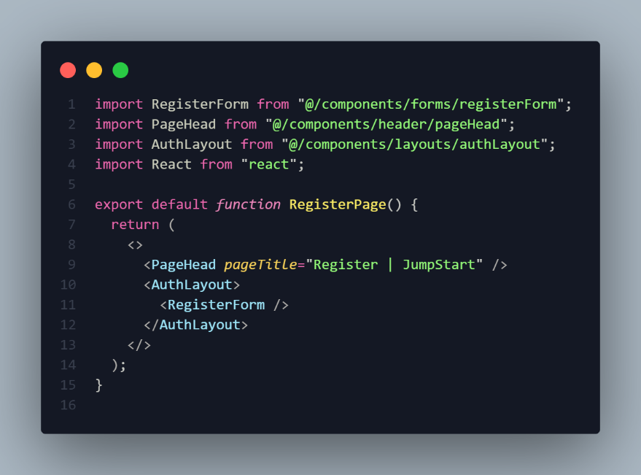**

**Dashboard  
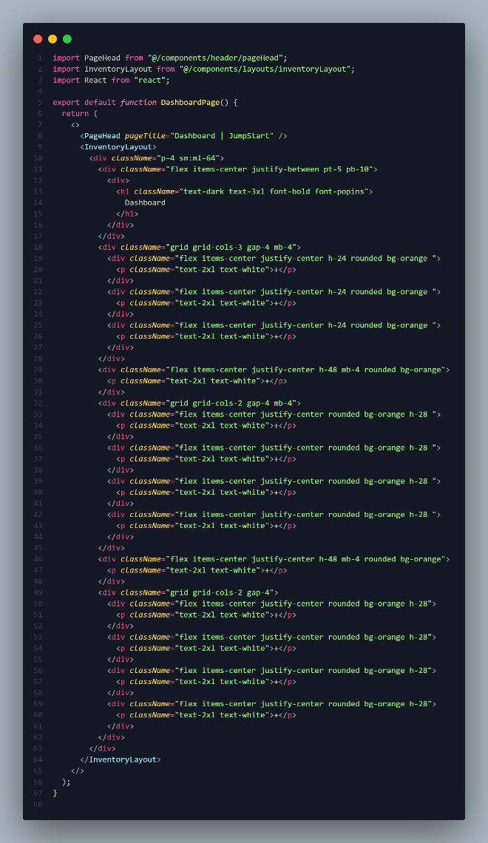**

**Inventory Page (Suppliers, Products, Costumers, Current Stocks, Sales Report, and Users Page)  
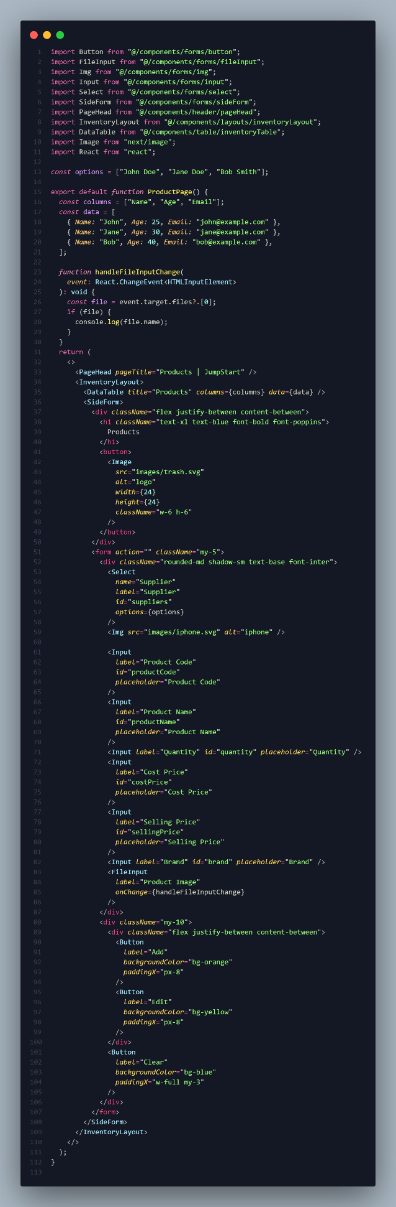**

**Project Prototype**

Link Prototype : <https://www.figma.com/proto/0oc5ULIxVjAbsDt9b2GZHL/E-Warehouse?page-id=0%3A1&node-id=133%3A123&viewport=828%2C-196%2C0.09&scaling=min-zoom&starting-point-node-id=133%3A123>   
Link UI Design : <https://www.figma.com/file/0oc5ULIxVjAbsDt9b2GZHL/E-Warehouse?node-id=133%3A426&t=DSr6Z1vjwk8sQkGF-1>

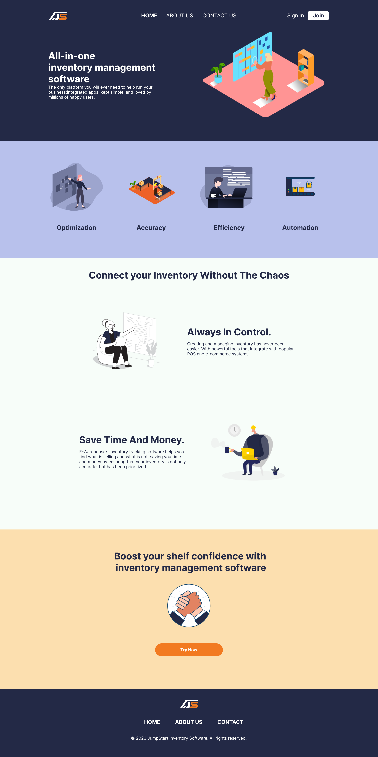  
Landing Page

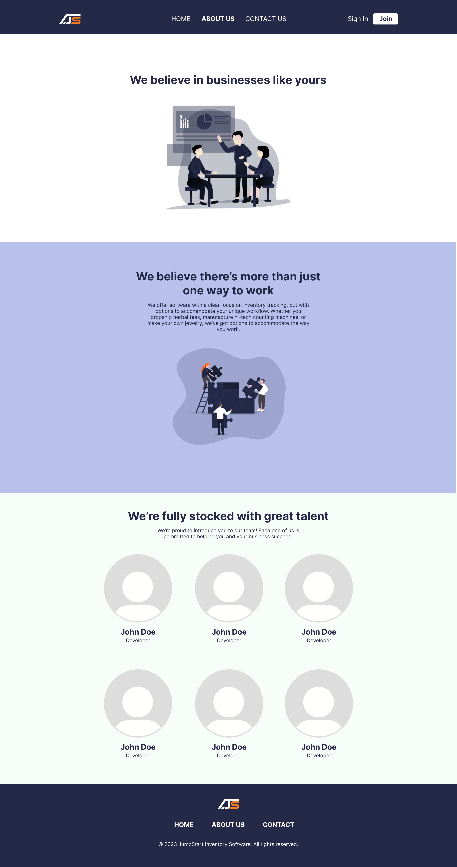

About Us

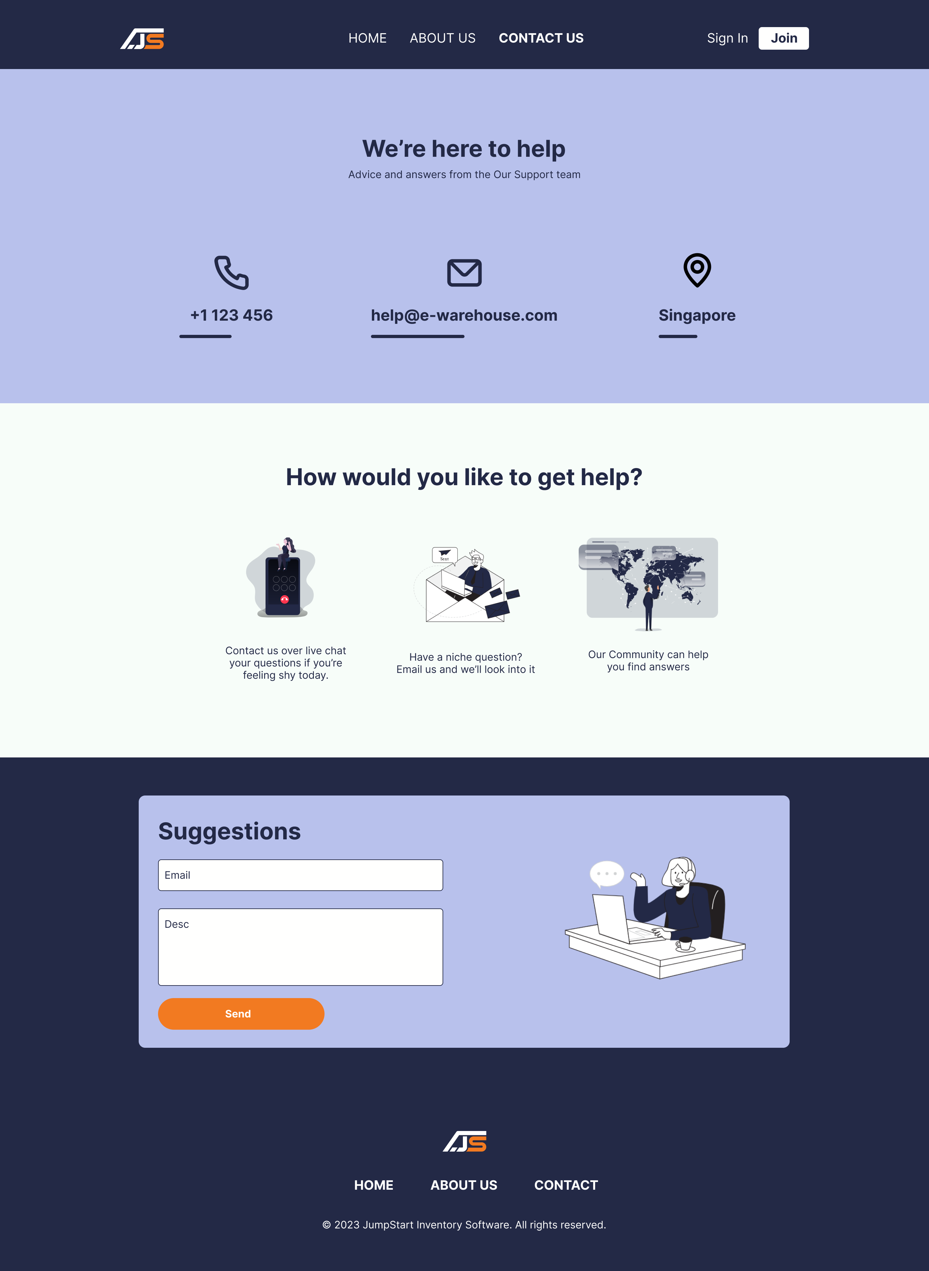

Contact Us

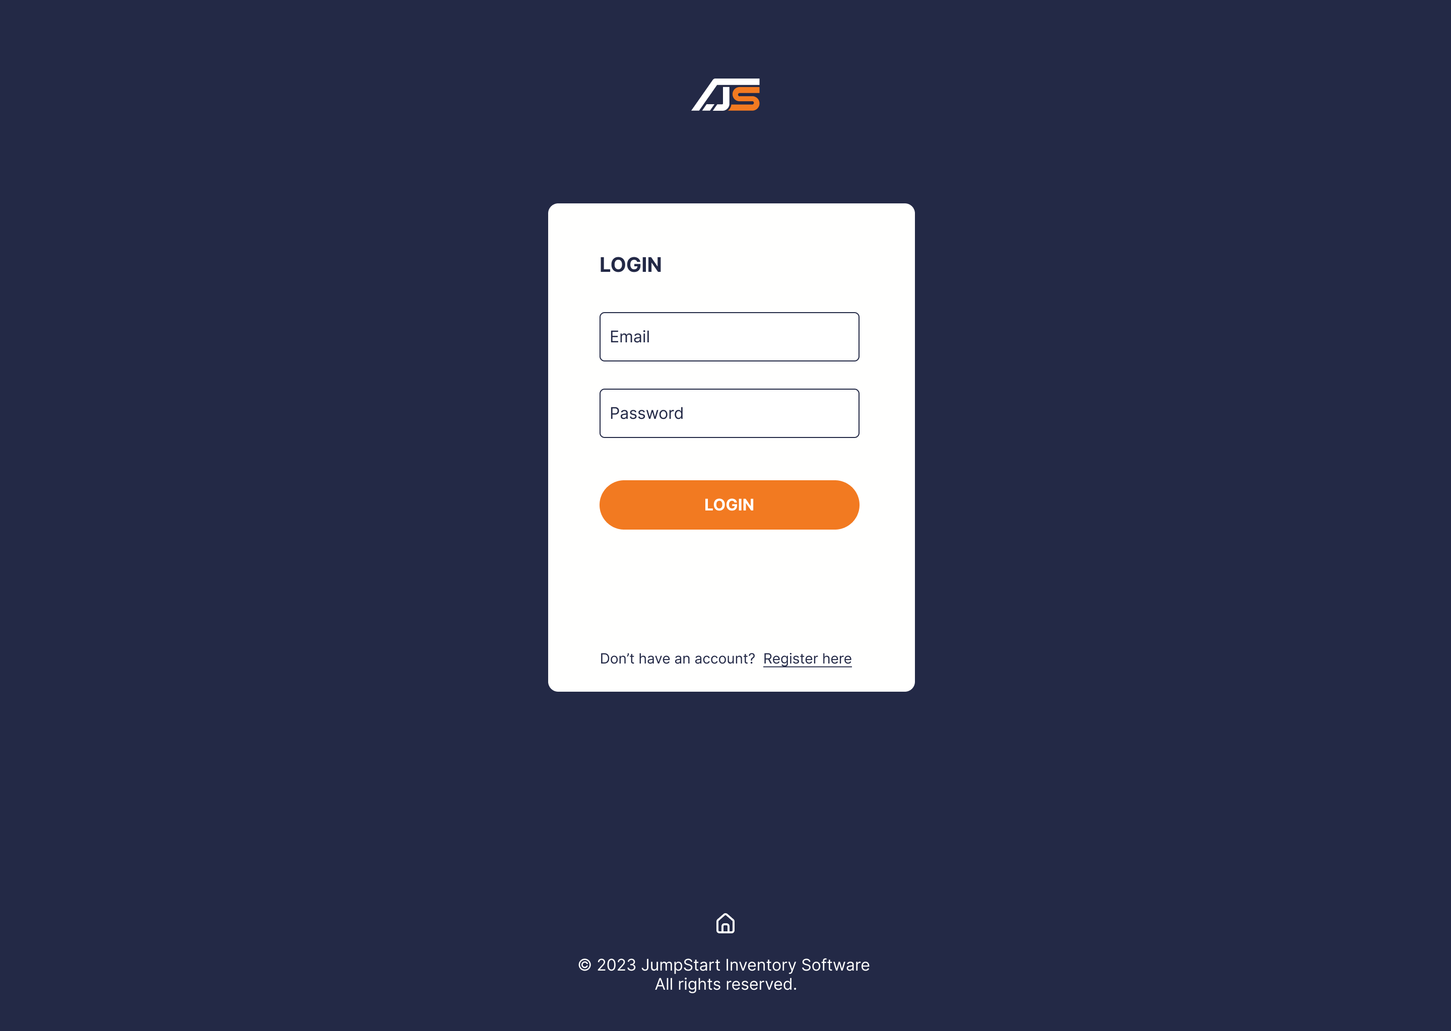

Register Page

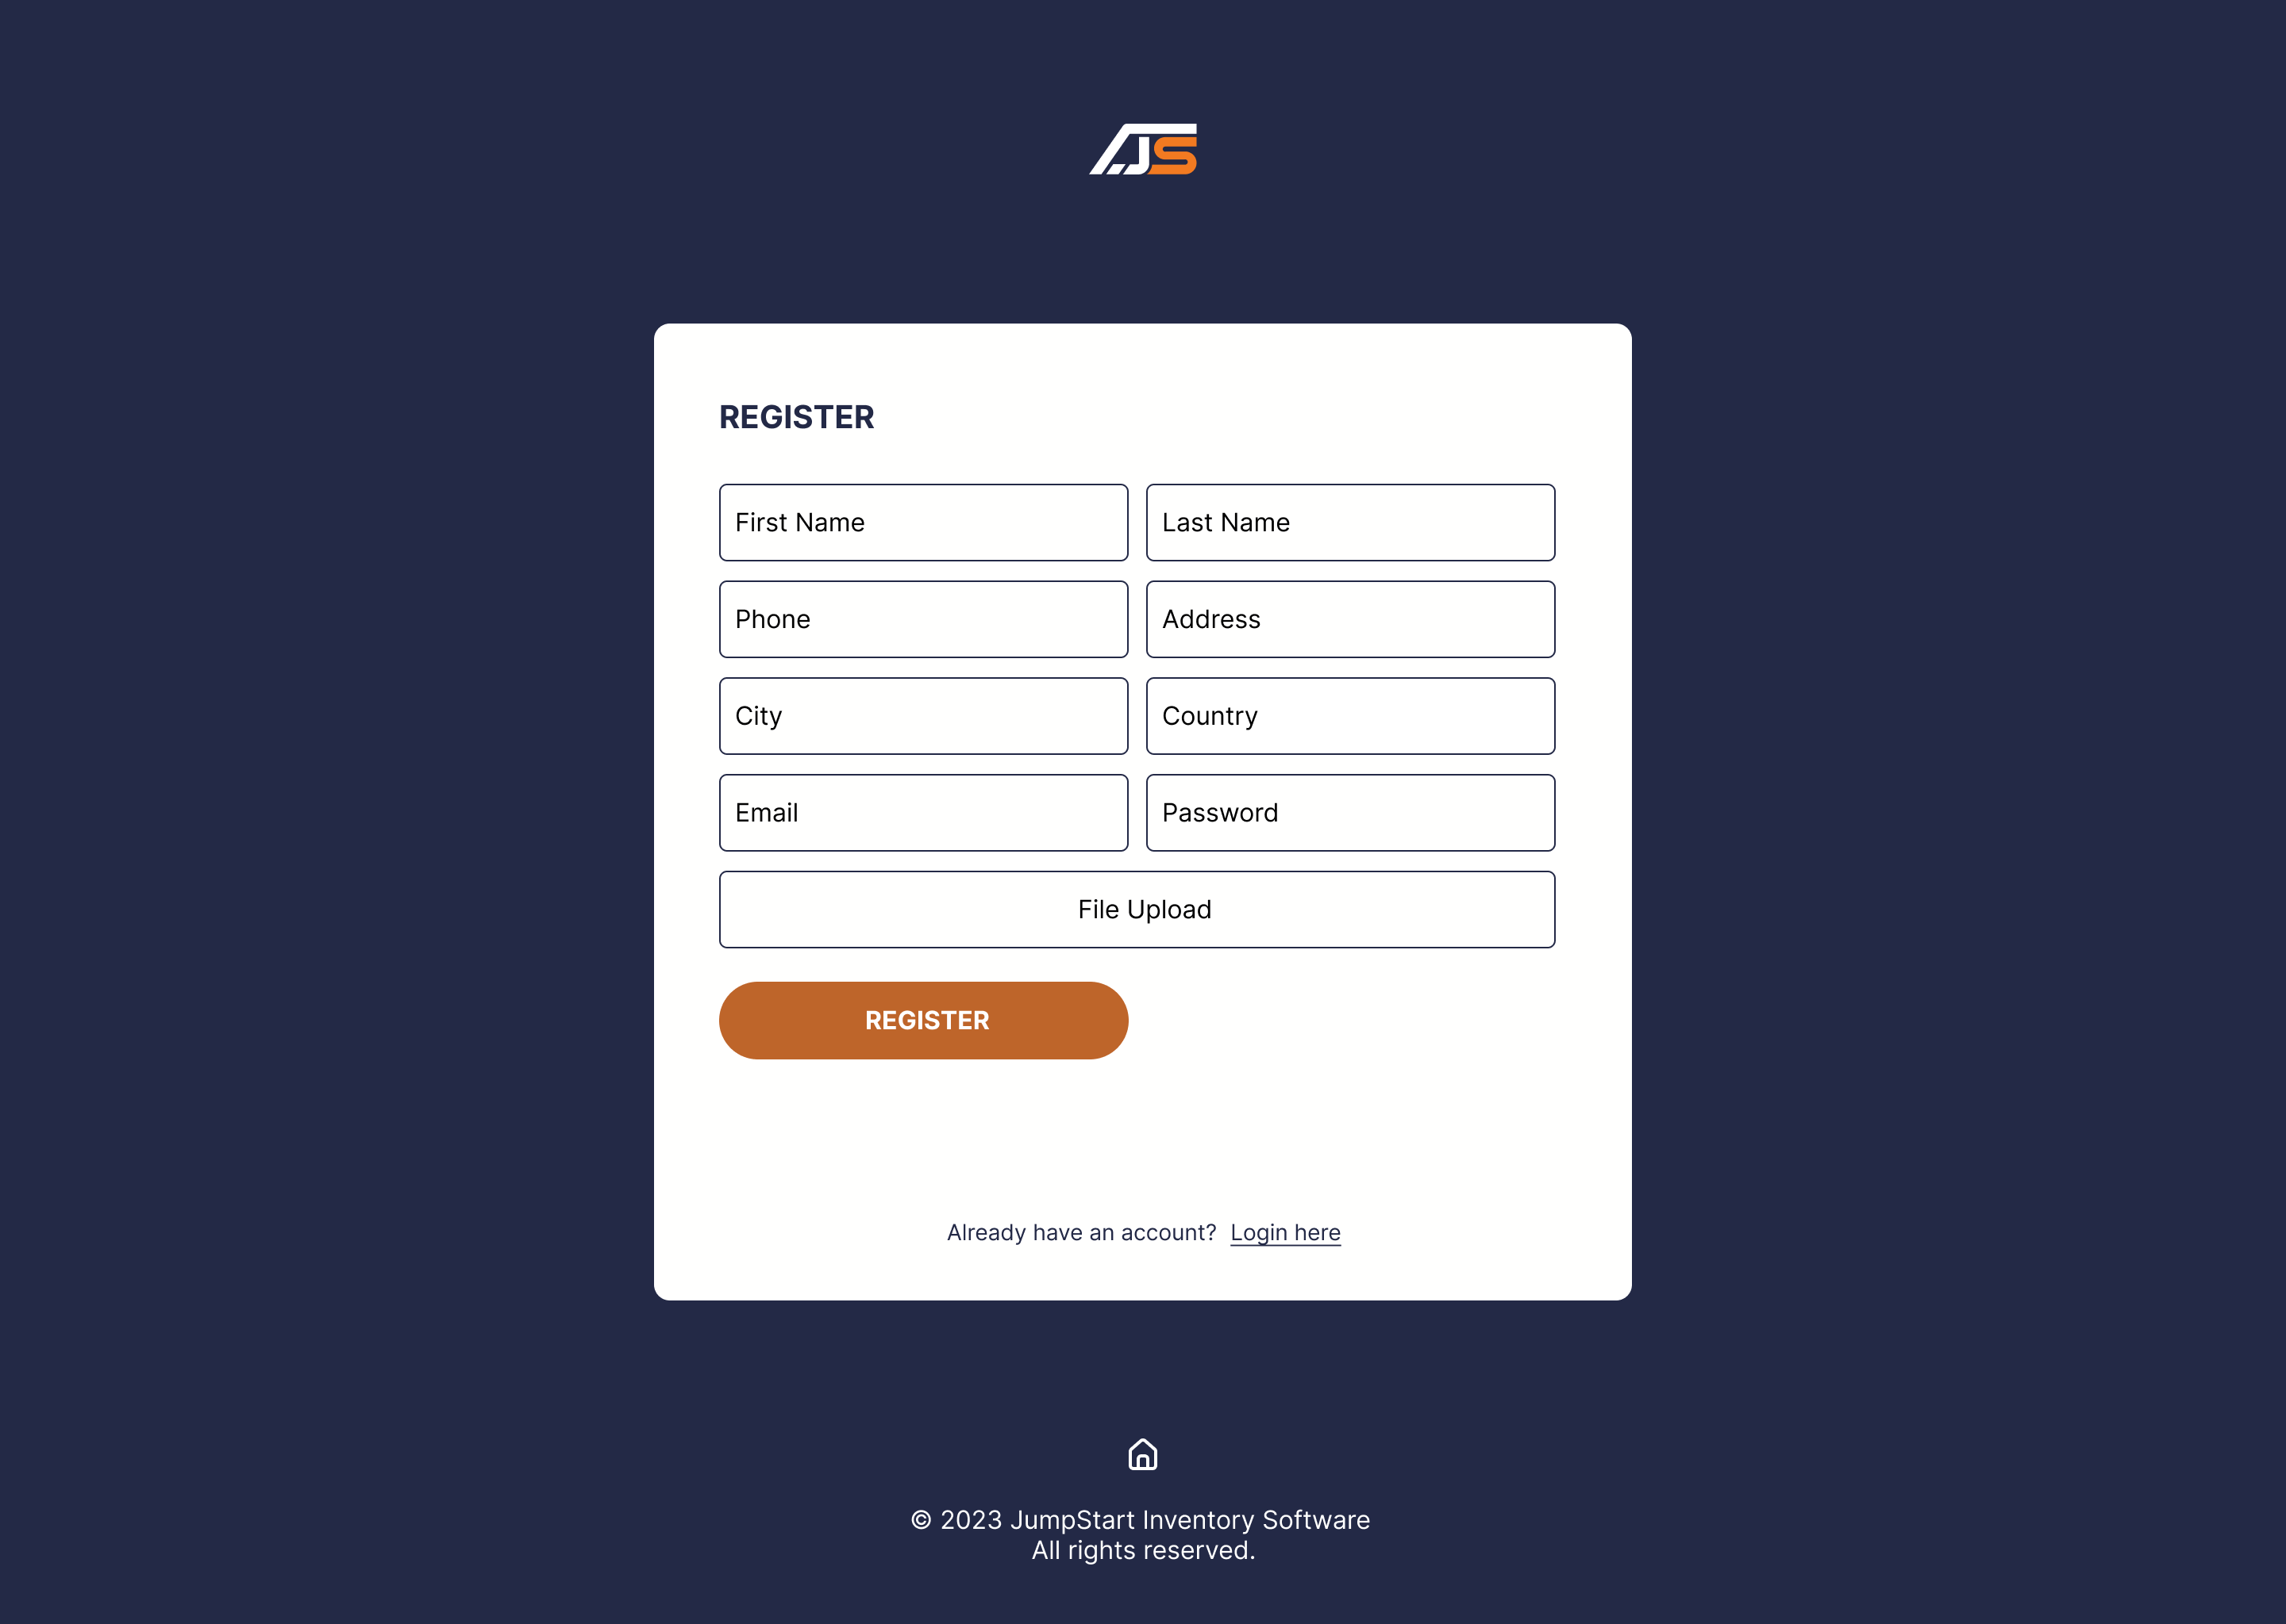

Login Page

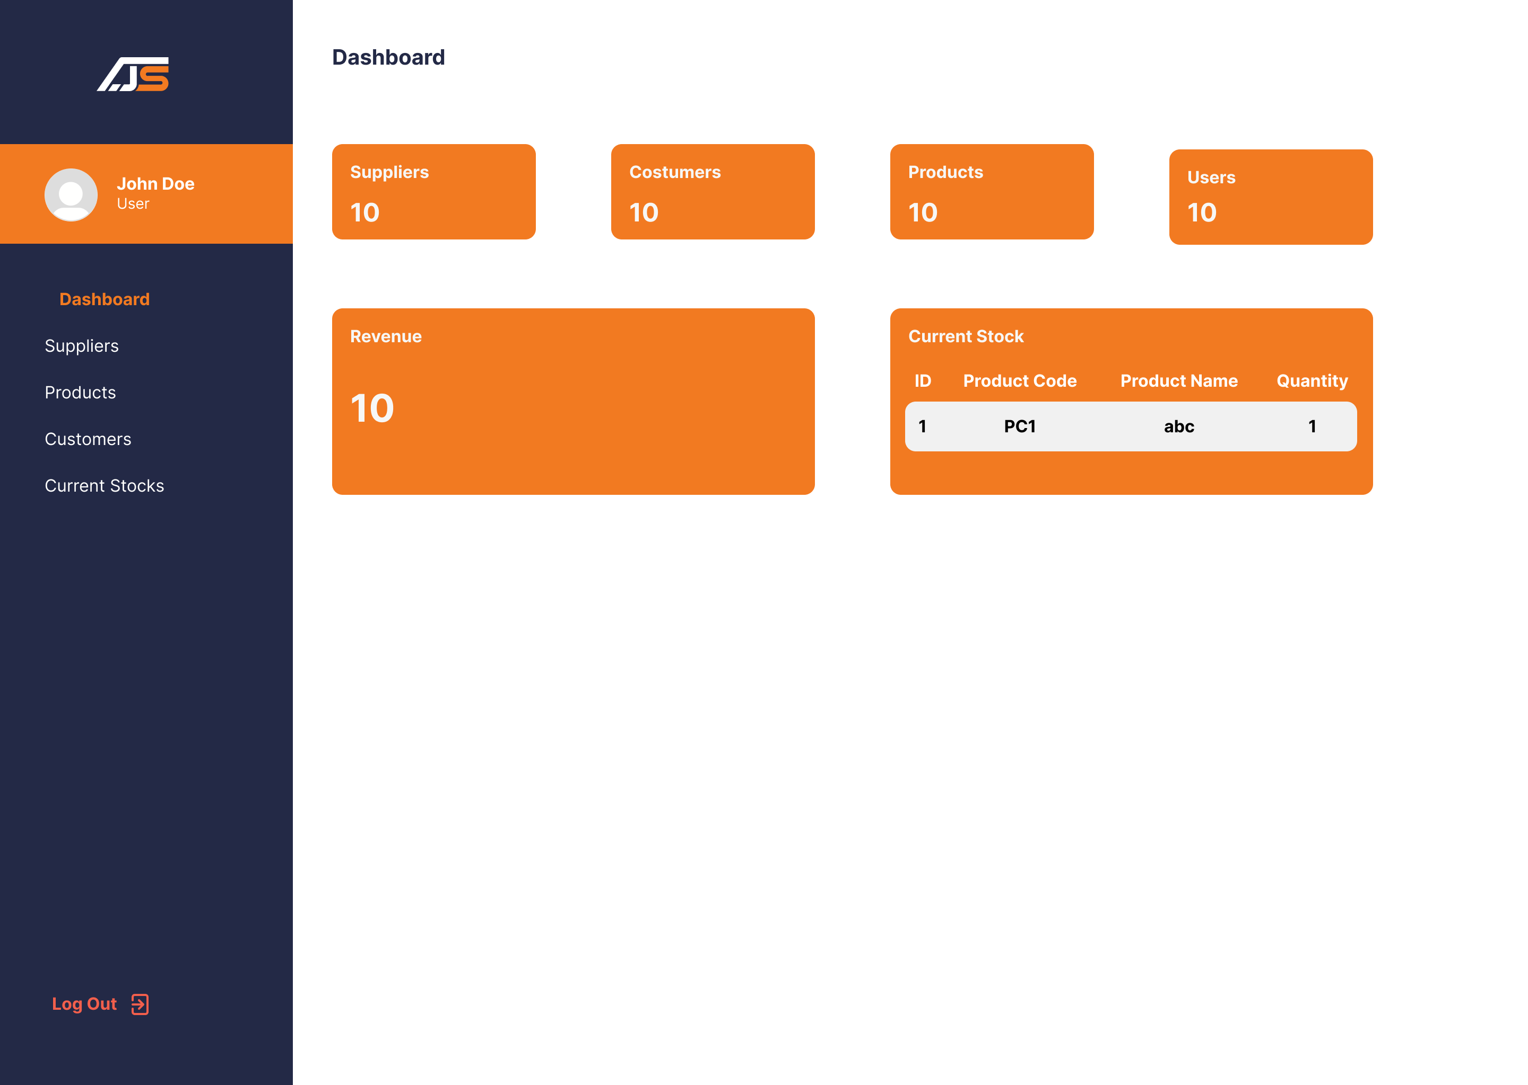

User Dashboard Page

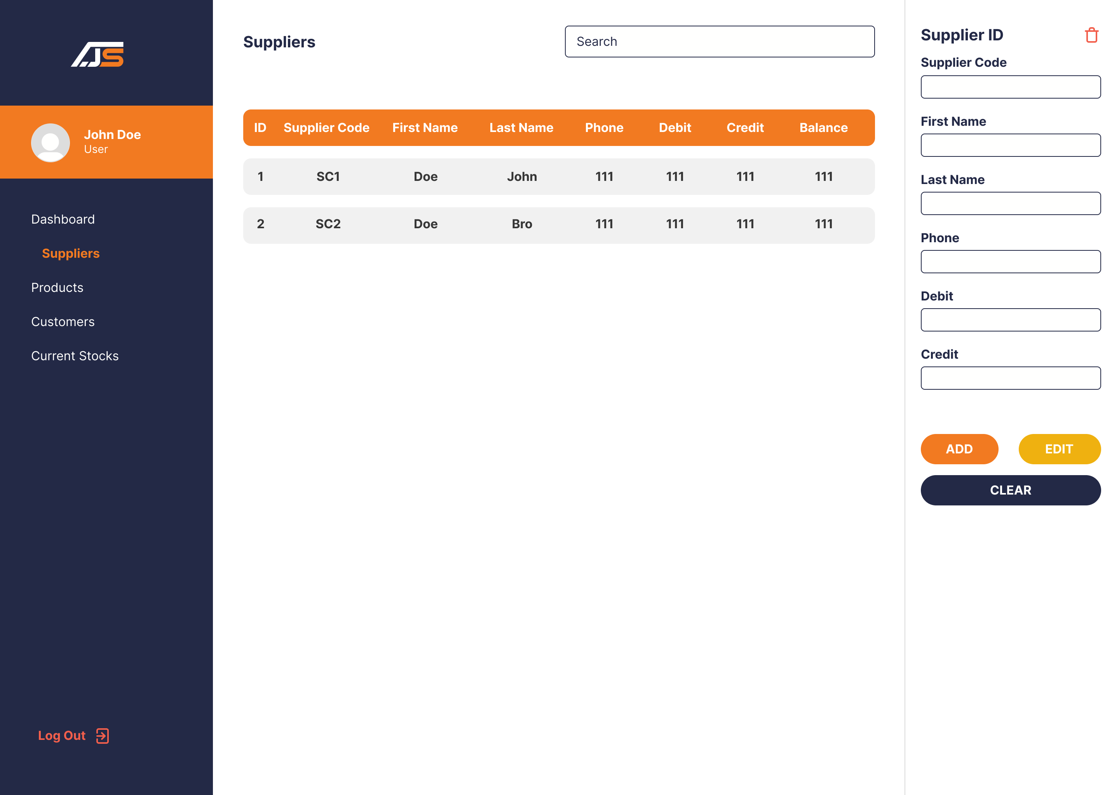

User Suppliers Page

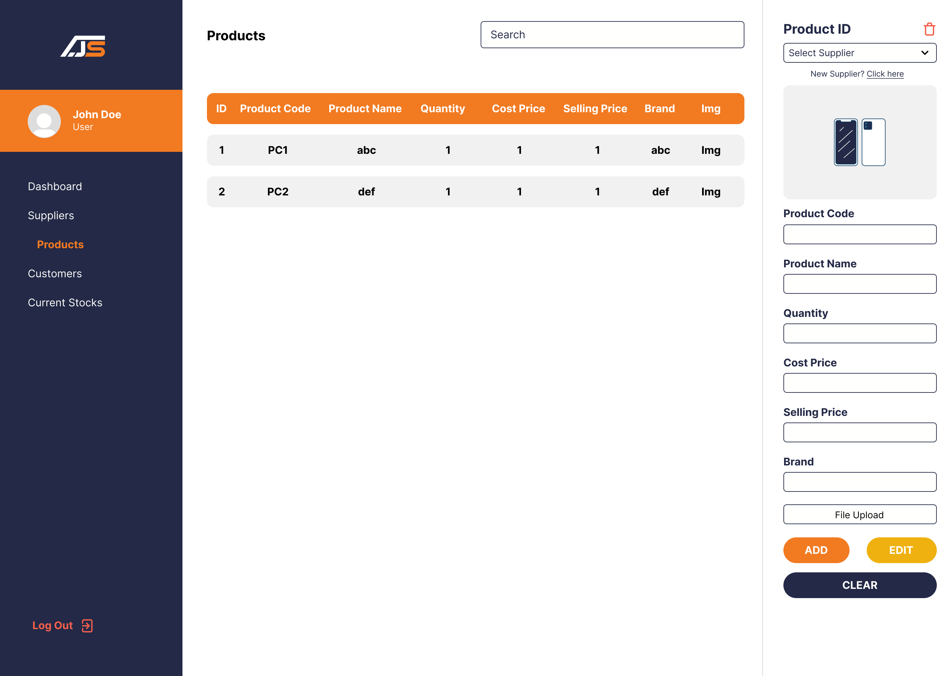

User Products Page

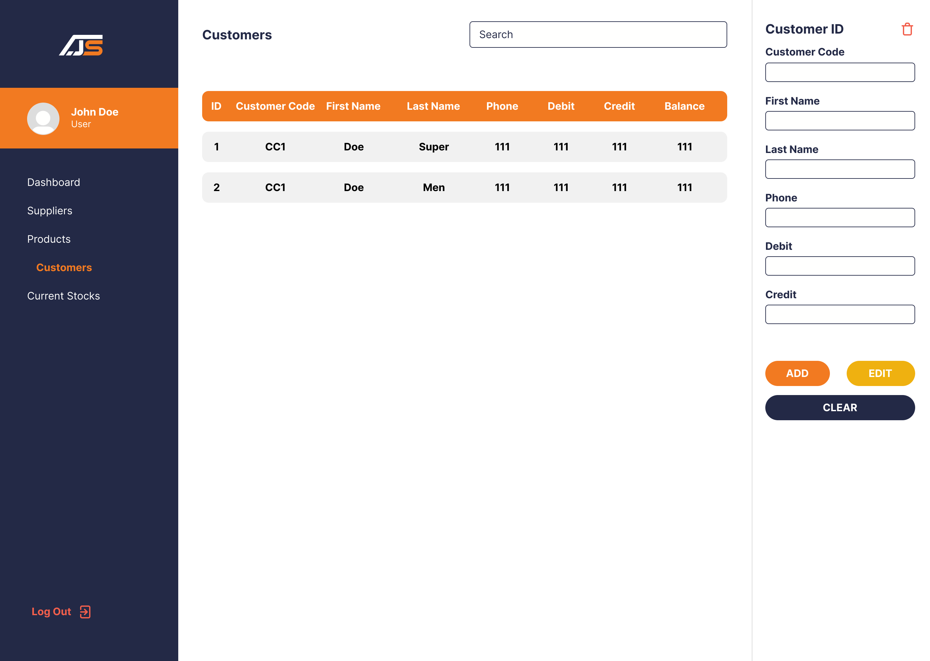

User Customers Page

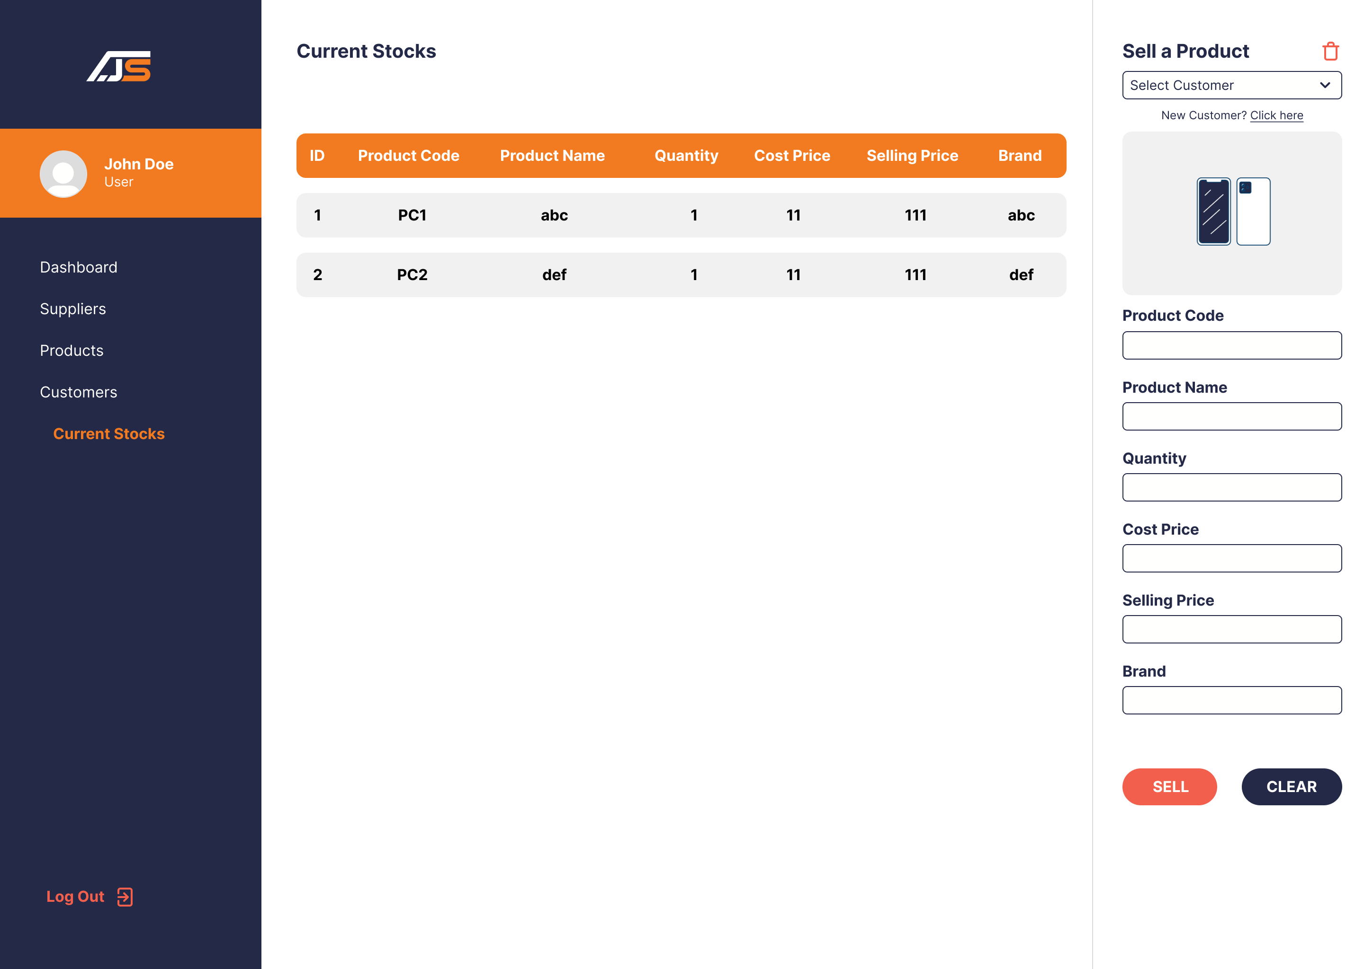

User Current Stocks Page

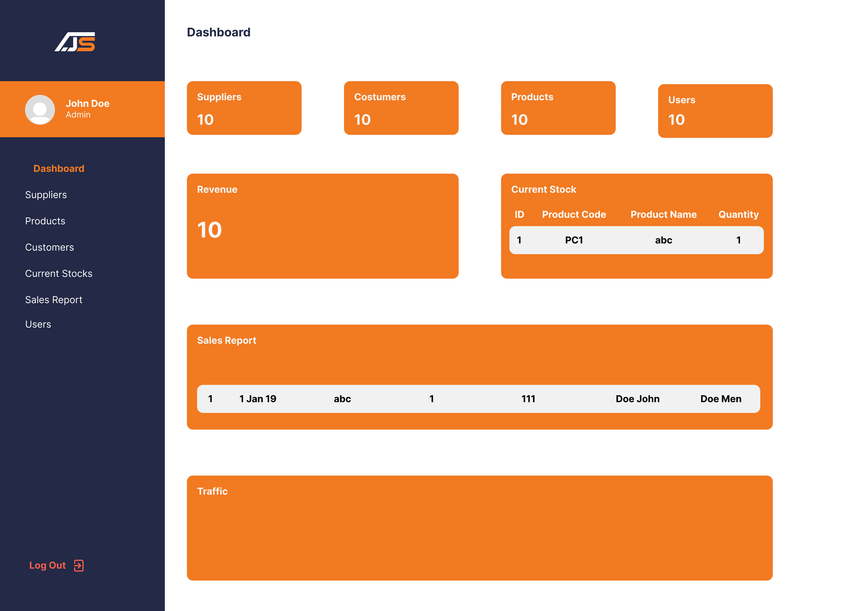

Admin Dashboard Page

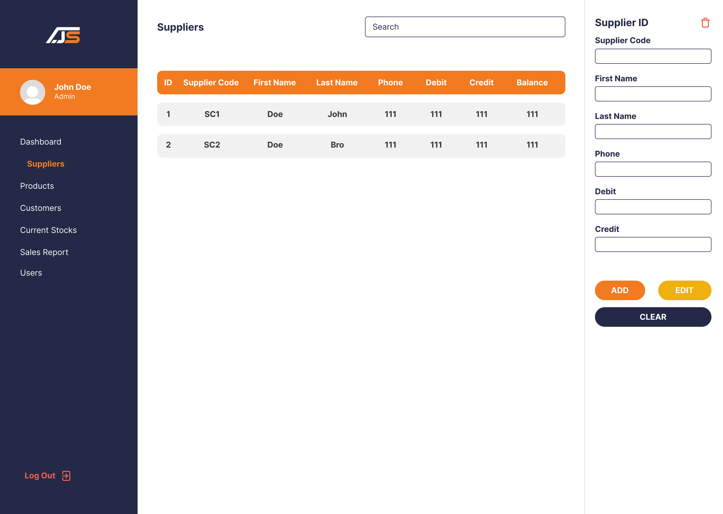

Admin Suppliers Page

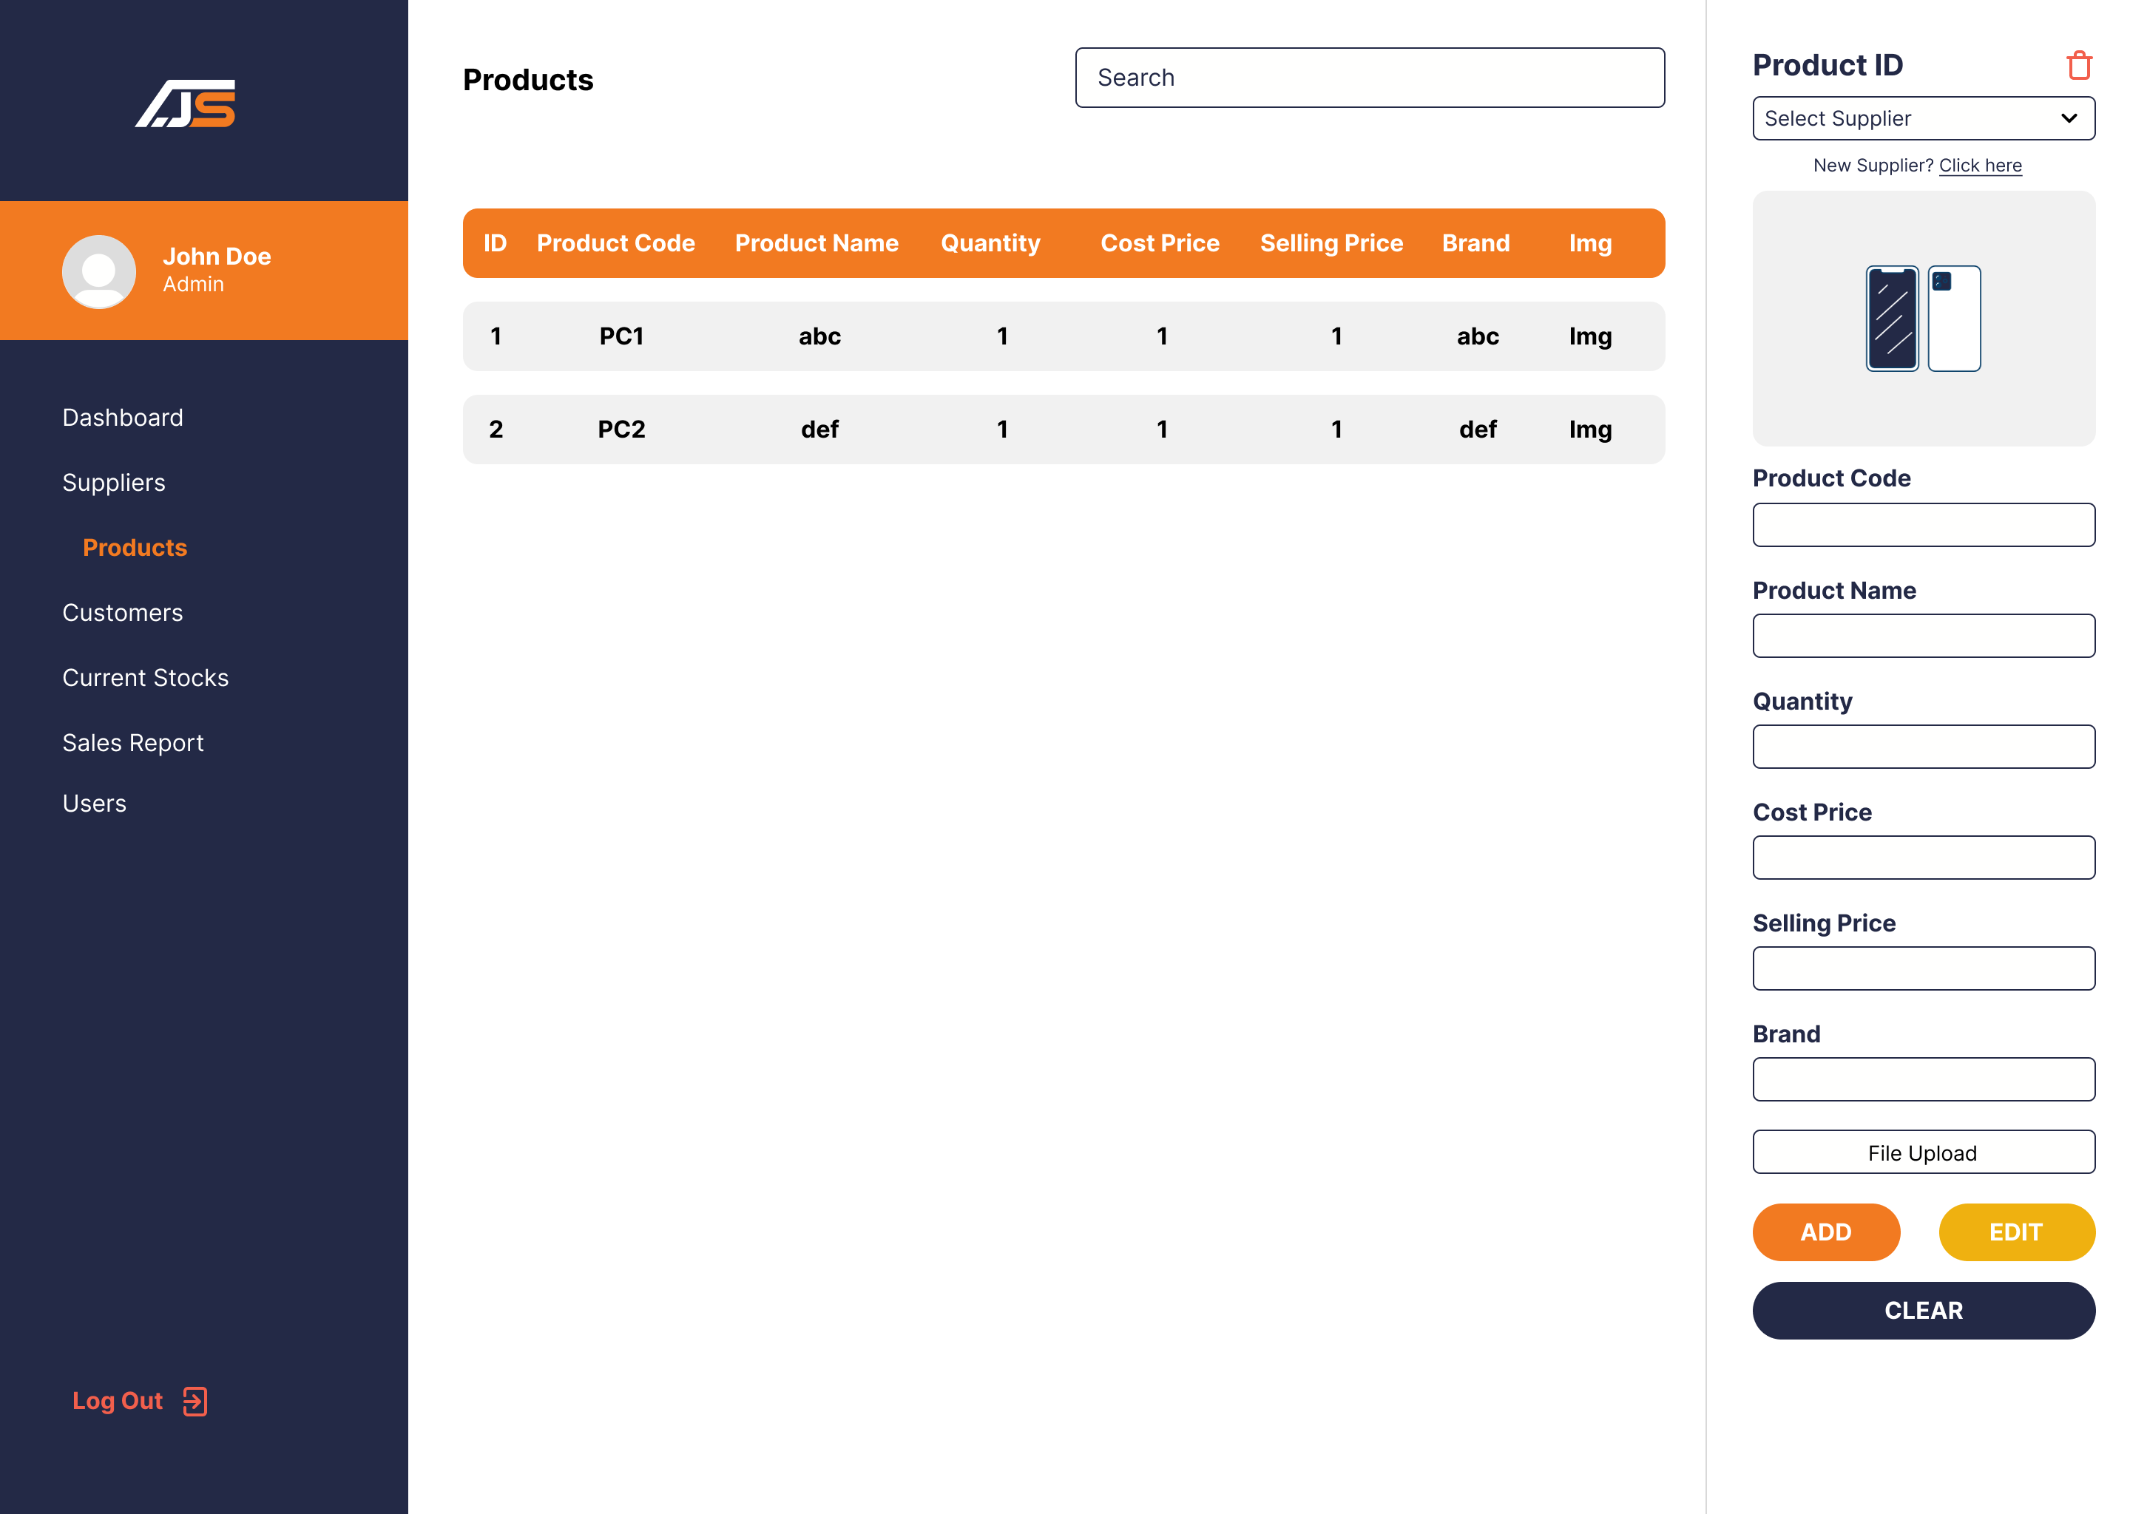

Admin Products Page

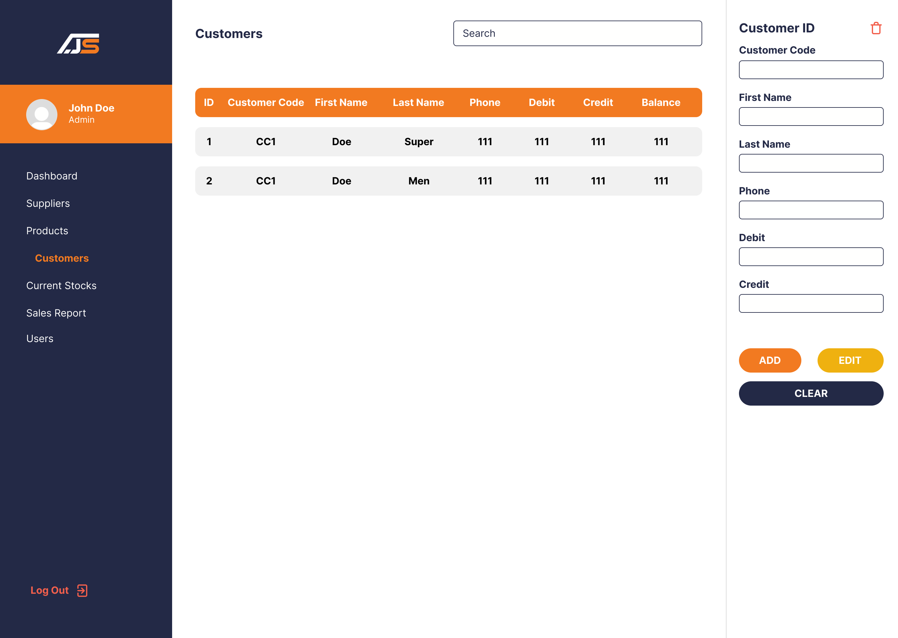

Admin Costumers Page

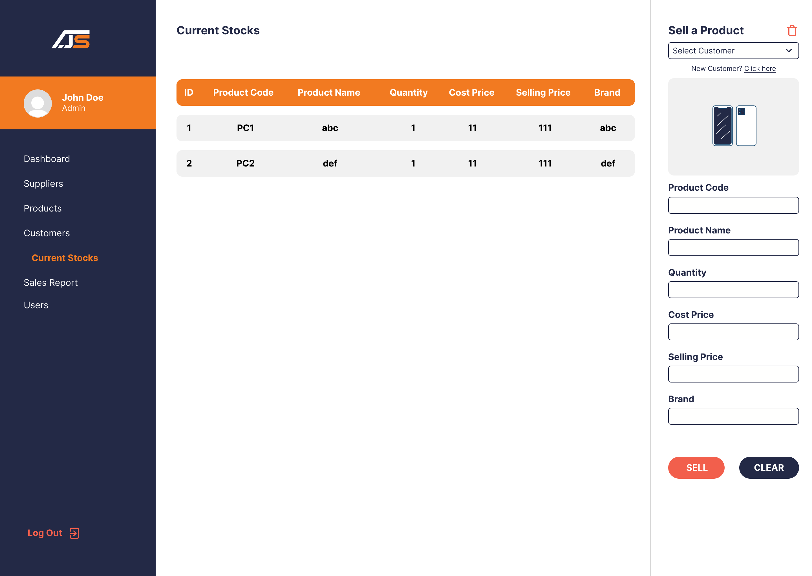

Admin Current Stocks Page

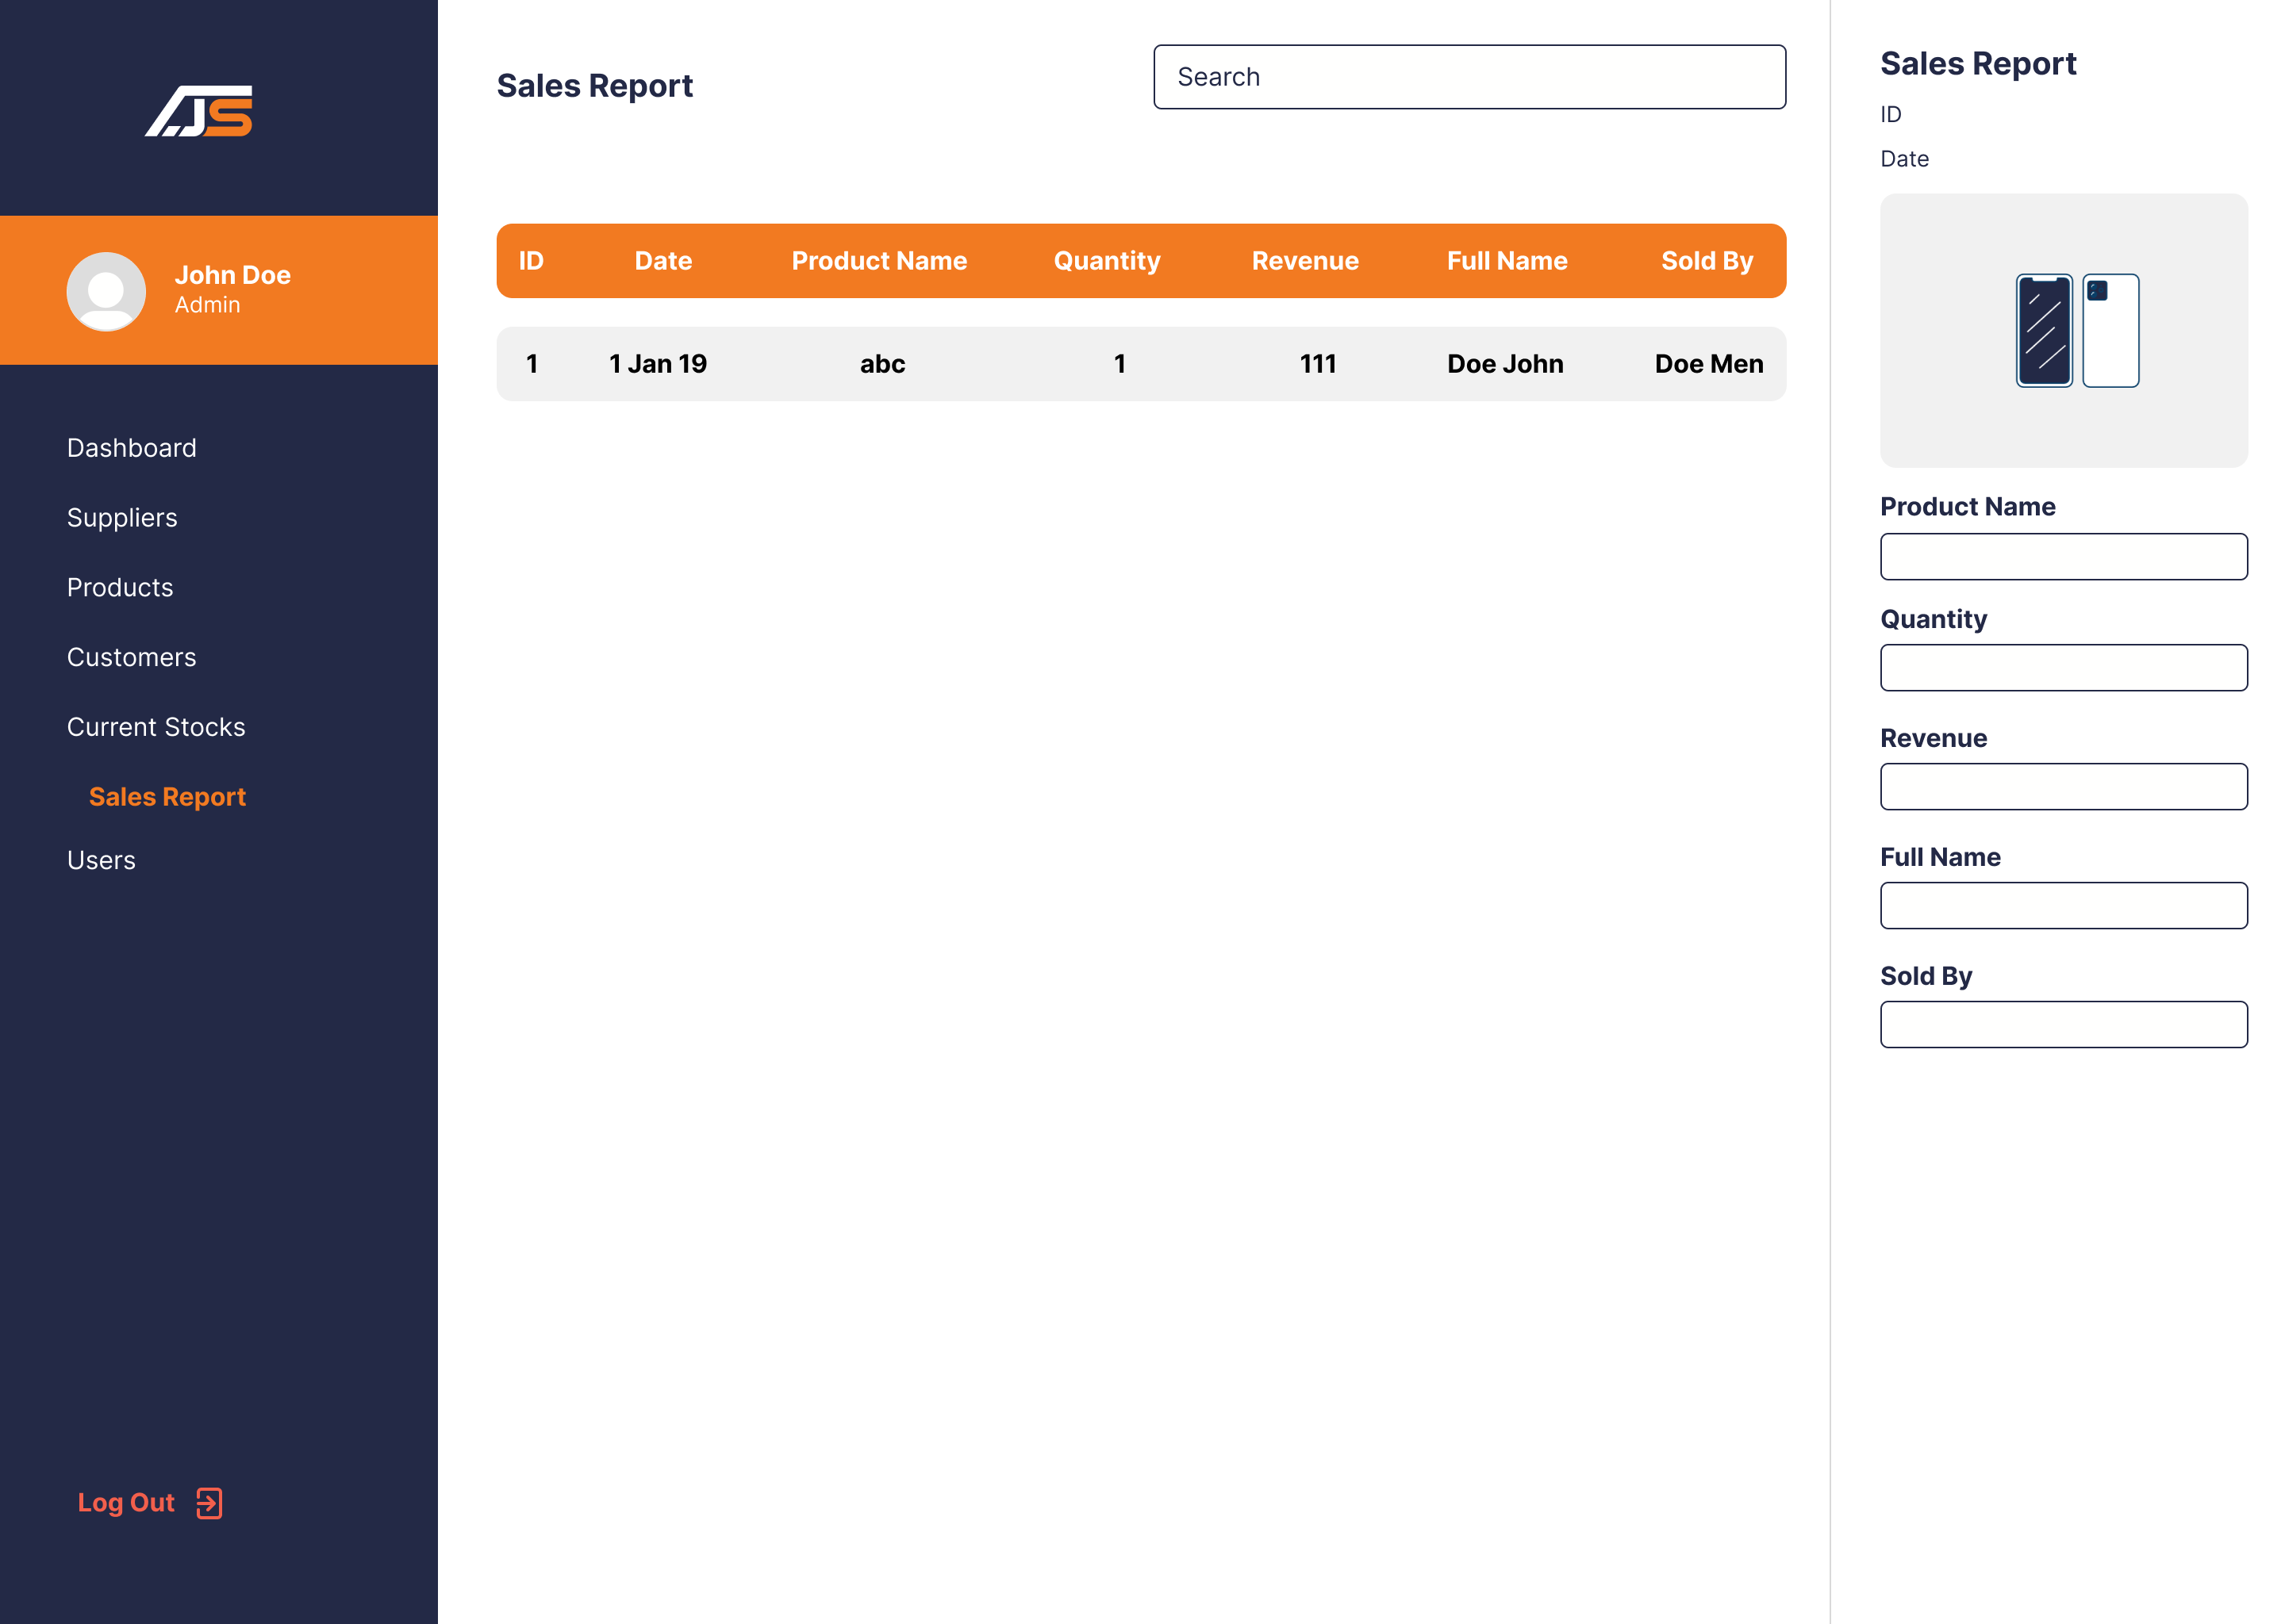

Admin Sales Report Page

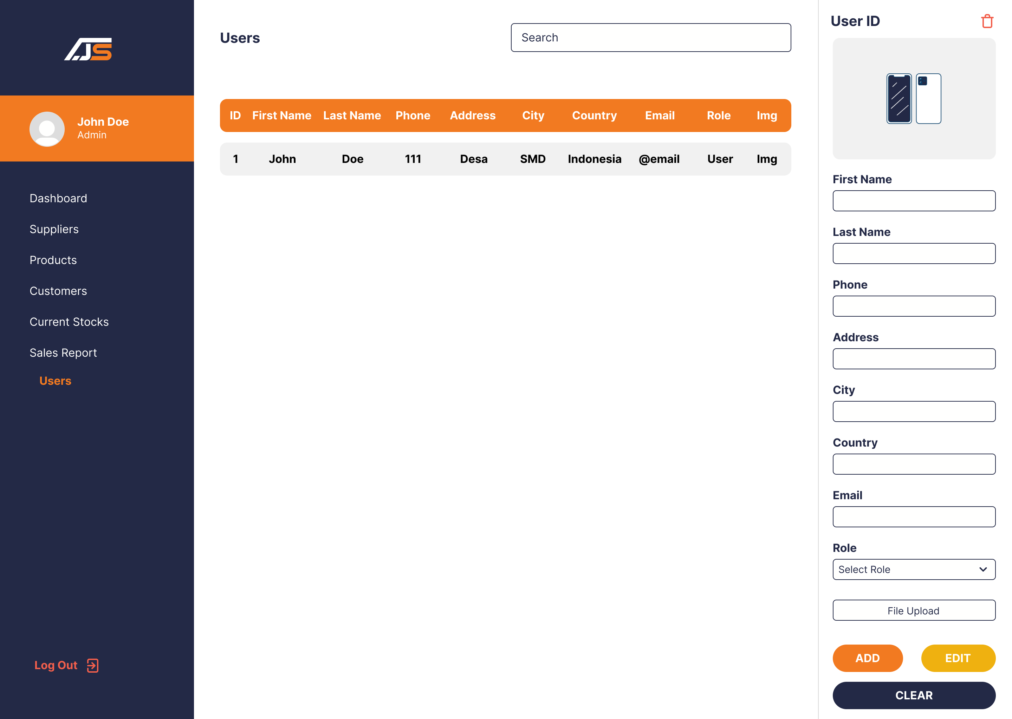

Admin Manage Users Page

1. **A description of the website's core functionality and features that have been implemented so far, along with any that are planned for the remaining development period.**

The website for the Jumpstart inventory management system is designed to provide an efficient and accurate way to manage inventory data. The core functionality includes the ability to add, update, and delete inventory items, track inventory levels, and generate reports on inventory status. The website also includes a user management system with different permission levels for accessing and editing inventory data.

Currently, the website allows users to perform basic CRUD (create, read, update, delete) operations on inventory items through a user-friendly interface. Users can view a list of all inventory items, filter and sort items based on different criteria, and edit item details. The website also provides real-time updates on inventory levels and generates reports on inventory status.

Planned features for the remaining development period include the integration of barcode scanning technology to streamline the inventory management process, as well as the implementation of a predictive analytics system to forecast inventory demand and optimize inventory levels. Additionally, the website will incorporate a data visualization system to help users better understand inventory trends and make data-driven decisions.

1. **Sample code snippets and database schemas that showcase the website's back-end functionality.**

**ERD  
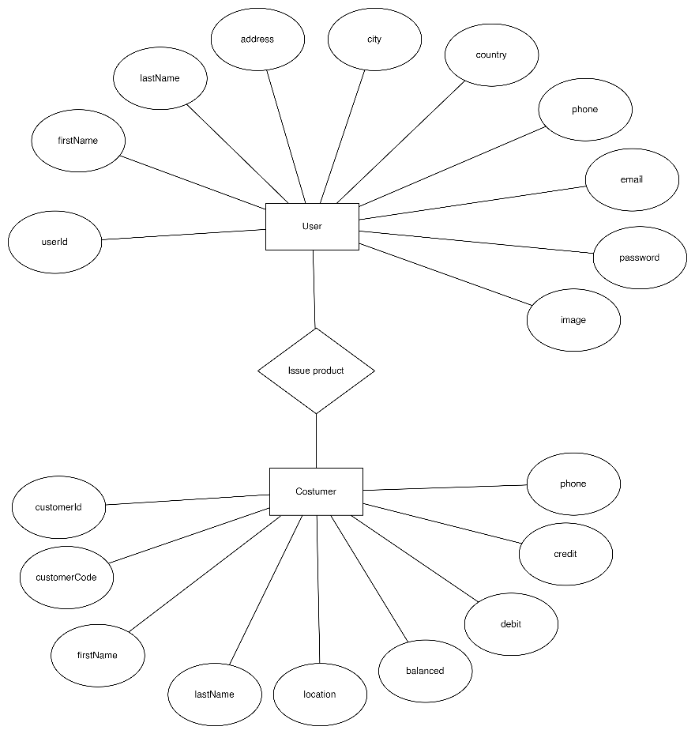**

Selling products to customers

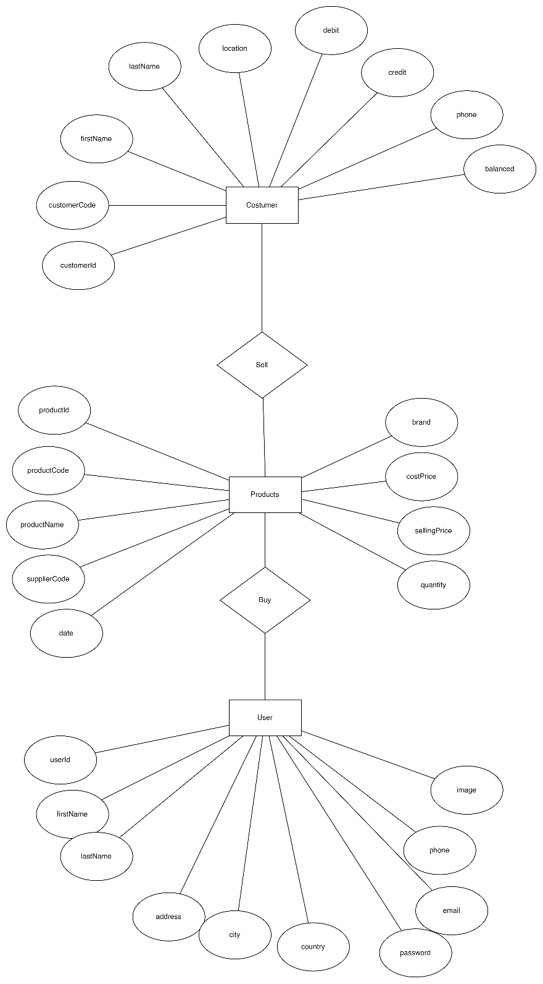Buying product from suppliers

**Schema Diagram  
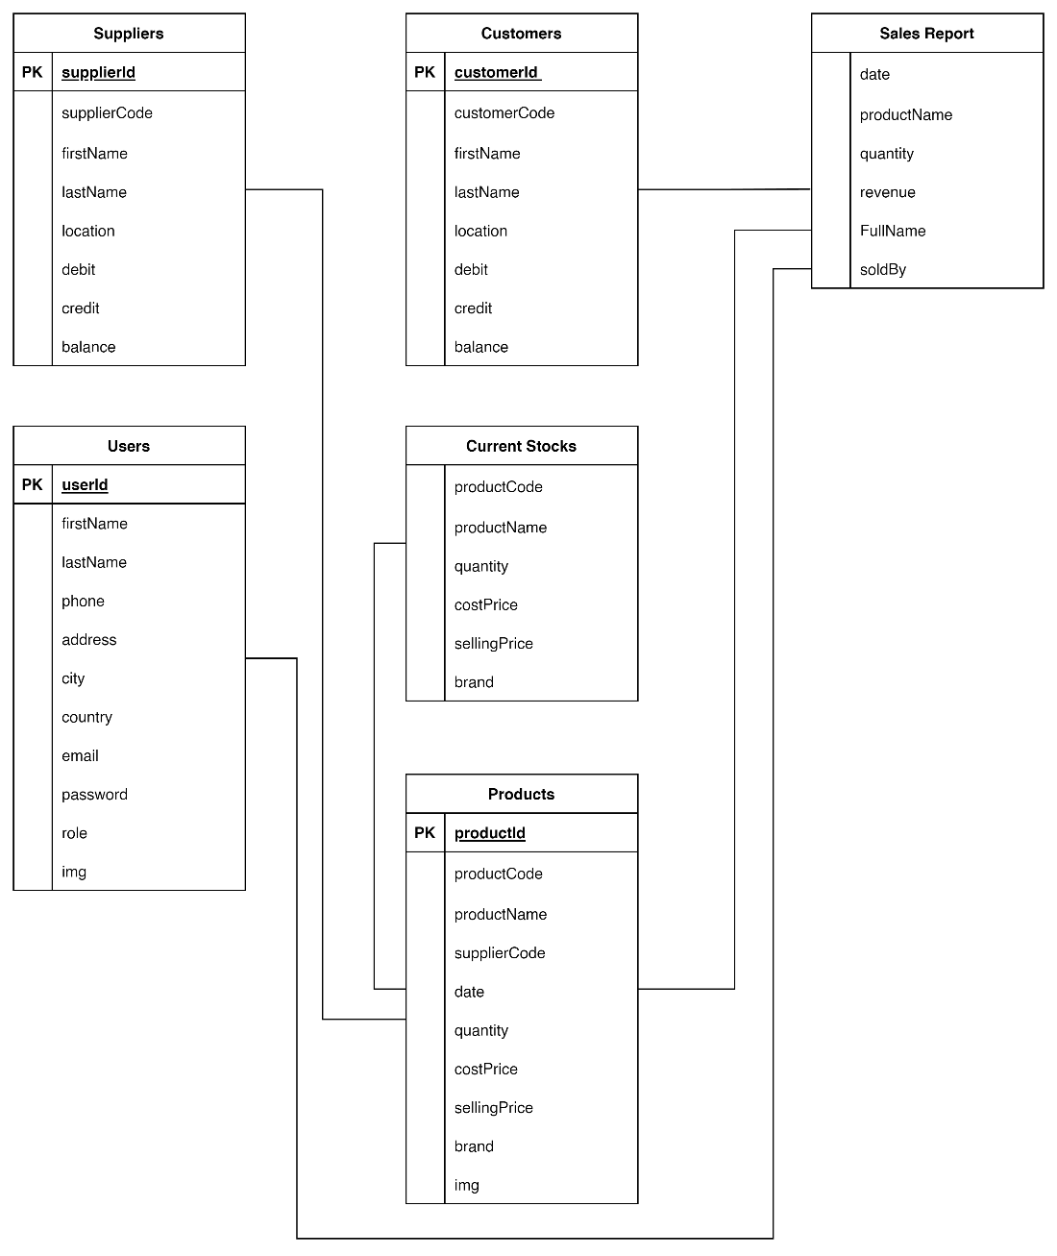**

**Database Tables  
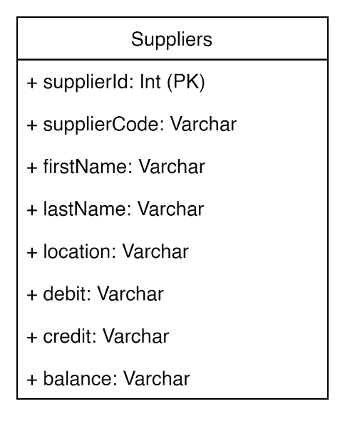 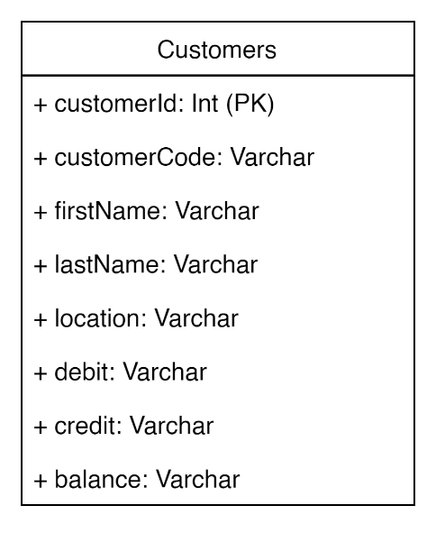 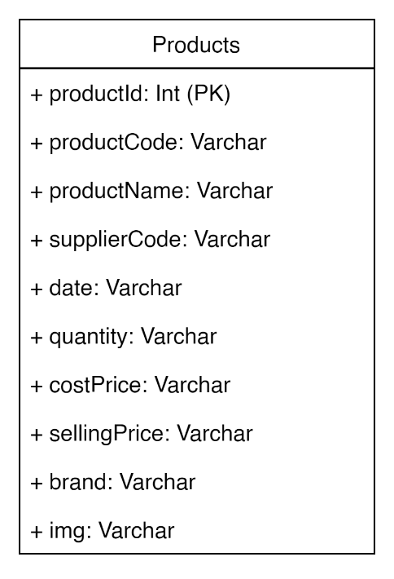 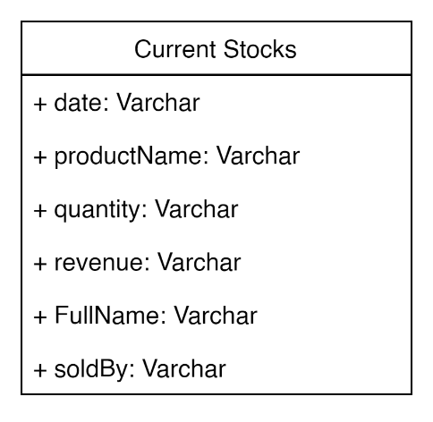 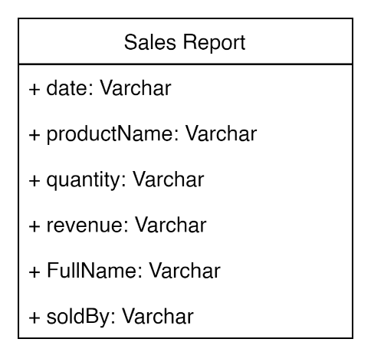 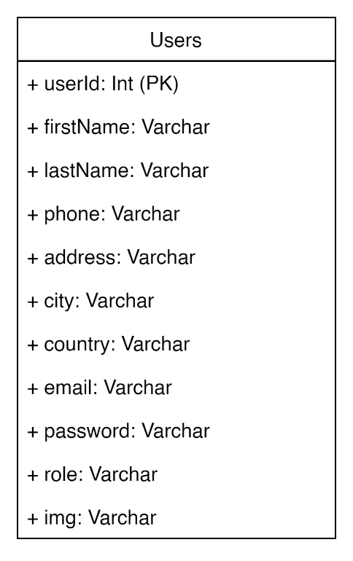**

**Costumer Model**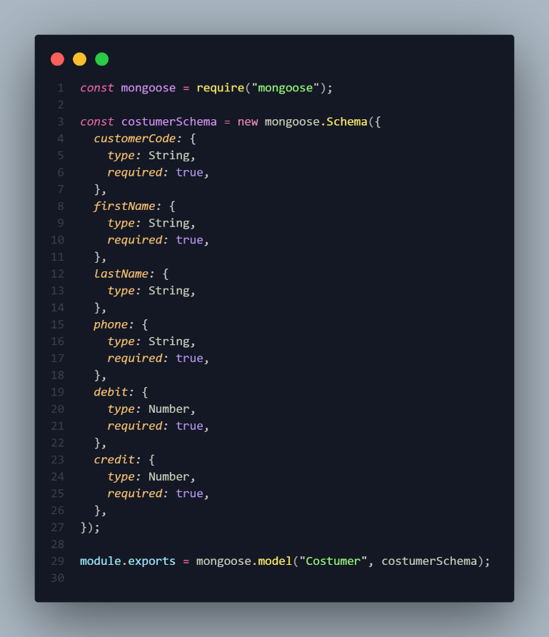

**Current Stock Model**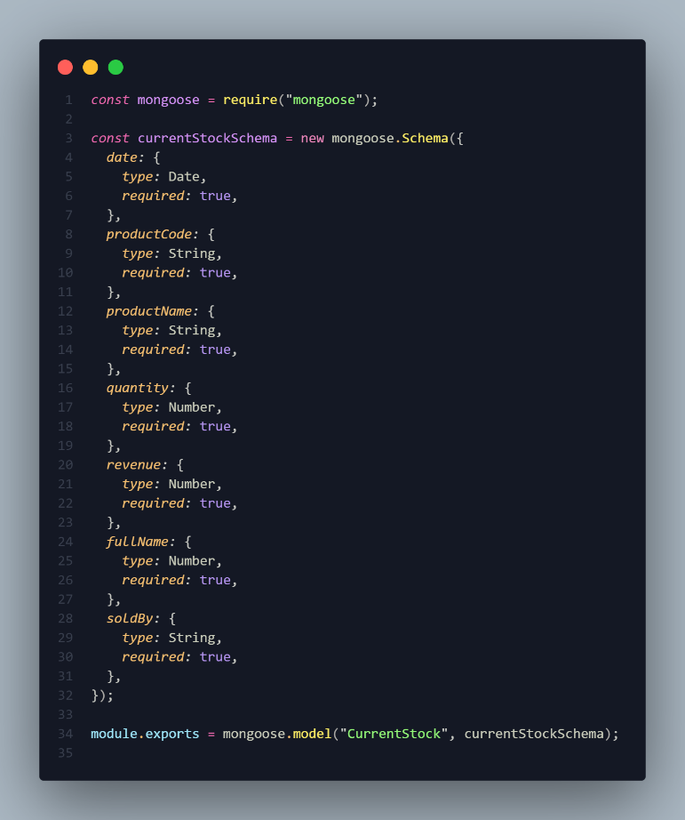

**Products Model  
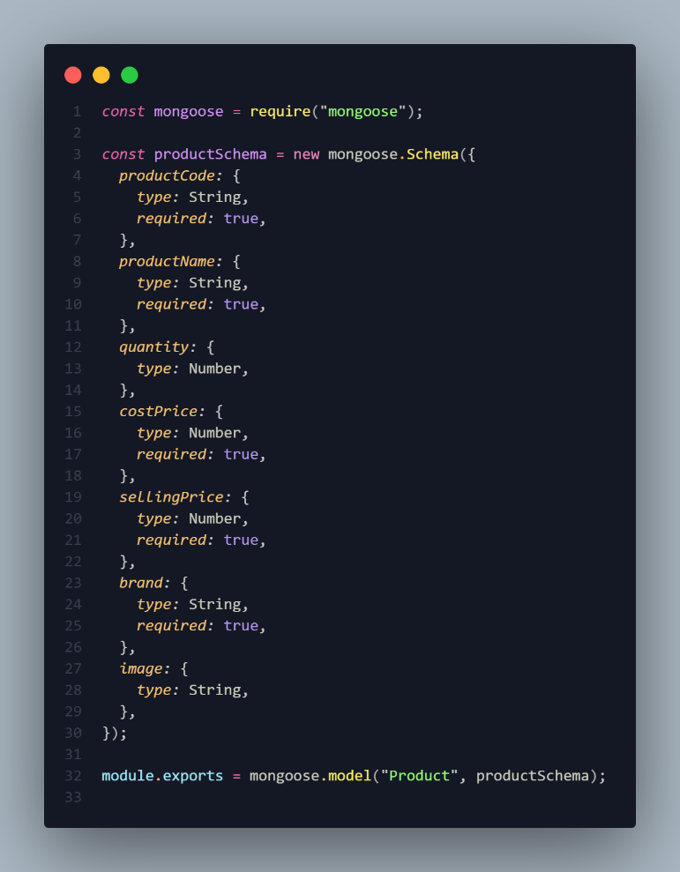**

**Sales Report Model  
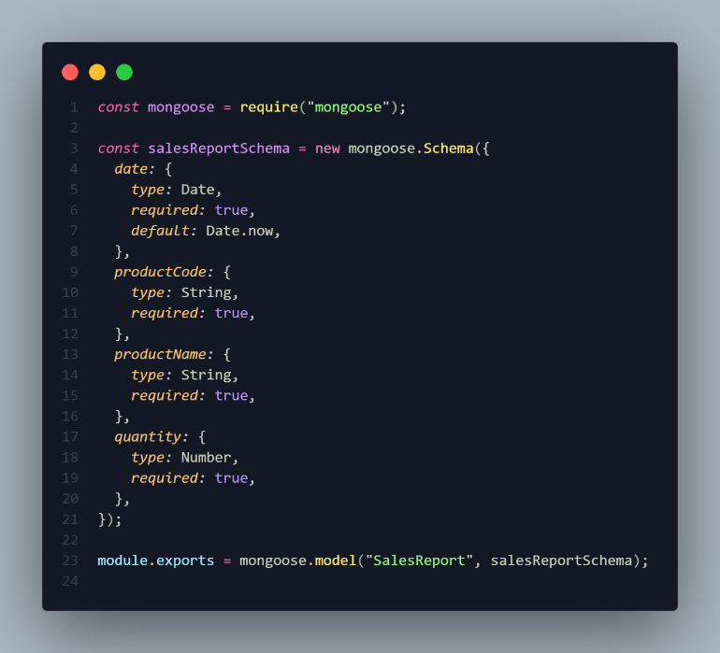**

**Supplier Model  
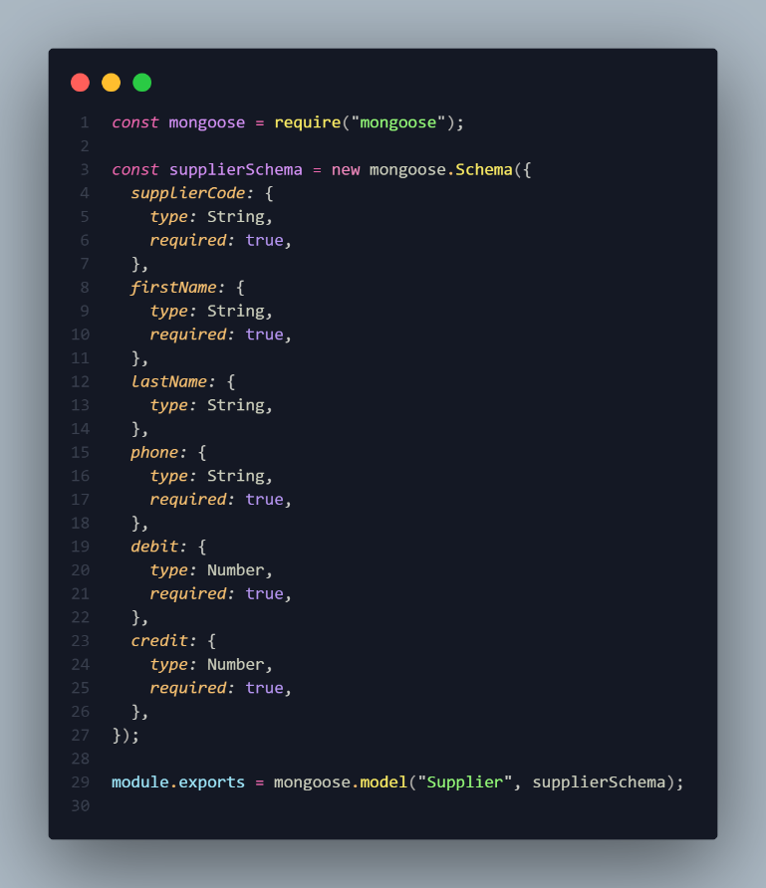**

**User Model  
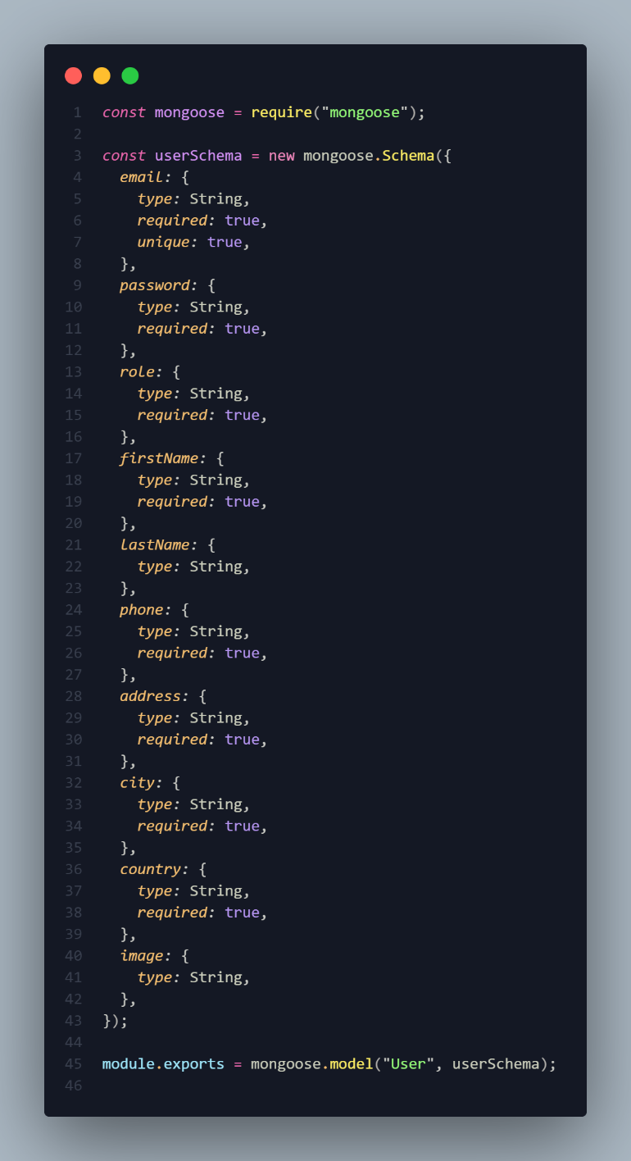**

1. **A detailed roadmap or timeline for the remaining tasks and deliverables, along with any changes or updates to the original project plan.**

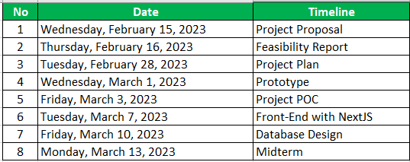

**Updates and Changes to the Original Project Plan:**

* The original project plan did not include integration testing or security testing, but they have been added to ensure the quality and security of the website.
* The timeline for deployment has been extended by one week to allow for additional testing and documentation.
* The training sessions for users and stakeholders have been added to ensure that they are able to use the website effectively.